30.51: a) 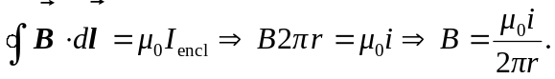
b) 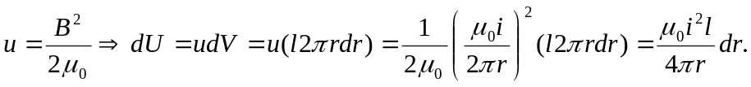
c) 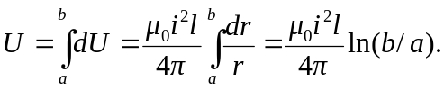
d) 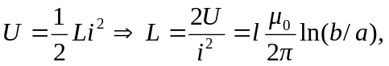which is the same as in Problem 30.50.

